

**Draft (May 2021)**

**International Water Management Institute**

**New Delhi**

Drought Proofing Assessment:

Ravanduru watershed, Mysore, Karnataka

Contents

1 Ravanduru watershed 3

1.1 Land Use & Soil 3

1.2 Cropping pattern 4

1.3 Irrigation & Domestic 5

2 Drought risk assessment 5

3 Drought proofing assessment 7

4 Application of drought proofing tool 9

4.1 Baseline scenario 10

4.1.1 Water balance 10

4.1.2 Crop water requirement and irrigation water requirement 10

4.1.3 Crop water requirement met and crop yield 11

4.1.4 Drought proofing and Quadrant 12

5 Plan water management interventions 13

5.1 Water management interventions scenarios 14

5.2 Interventions impact on moderate drought 15

5 Conclusion and recommendation 18

Appendix A: Input data 20

# **Ravanduru watershed**

Ravanduru watershed is located in the Periyapatna Block of Mysore District in Karnataka, India (Figure 1a). Watershed is part of Cauvery basin. Total area of the watershed is 2285 hectares (ha). The study area has received well-distributed rainfall over the year with average annual rainfall of 842 mm (1980-2017). Mysore has Bimodal rainfall with peak in May and October (Figure 1b). Also, rainfall is associated with high inter-year variability (Pai et al., 2014). Average annual mean temperature is 23.8 ᵒC with minimum temperature observed in December with mean of 20ᵒC and maximum temperature is observed in May with mean of 26.1 ᵒC (Srivastava et al., 2009).

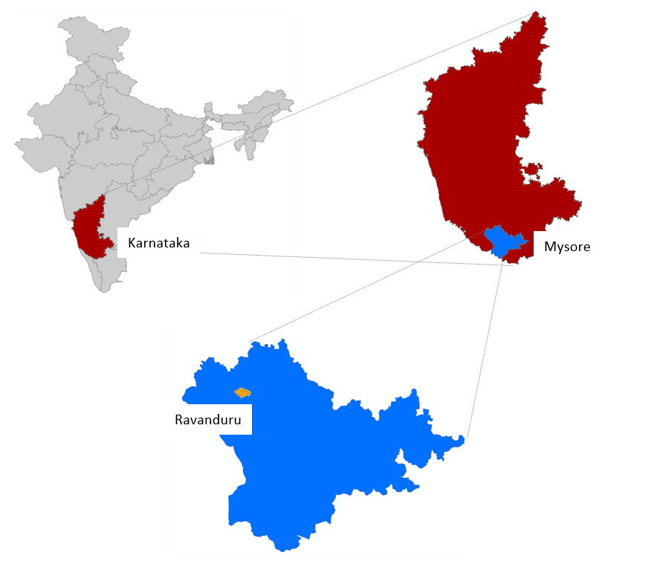

Figure 1 a) Study area map and b) Mean monthly rainfall and temperature of Ravanduru

## **Land Use & Soil**

Watershed is predominantly cultivated with agricultural area occupying ~ 82 % of watershed area (Table 1). Forest makes up ~ 6 % of watershed area. Sandy loam is the predominant soil type in the area covering 90% of in the area whereas rest is covered by loam soil.

Table 1: Land use details of Ravanduru watershed

|  |  |  |
| --- | --- | --- |
| S.no | Description | Area (ha) |
| Total Agri catchment Area (ha) | | 2285 |
|  | Agriculture Area (Net cultivated sown area) | 1865 |
|  | Fallow | 37.4 |
|  | Built-up / Settlements | 68.3 |
|  | Water bodies | 128.3 |
|  | Pasture | 28.5 |
|  | Forest | 130.3 |
|  | Waterbodies | 0 |
|  | Other | 27.12 |

## **Cropping pattern**

There are two main cropping seasons in the watershed: Kharif (overlapping monsoon season, May to Sep) and Rabi (post-monsoon season) ( **Figure 2**). In the kharif season, the major crop grown is Tobacco, followed by small cultivated area of Ginger and Red Gram. Tobacco crop is primarily rainfed but equipped for supplemental irrigation.

In the rabi, major crops grown are Ragi followed by a relatively small cultivated area of Cowpea, Maize, and Paddy. Rabi crops (post-monsoon season) are completely rainfed, relying on northeast monsoon rainfall (Oct to Dec). Supported by well-distributed rainfall in Kharif and Rabi season, cropping intensity is high (~ 199 %) in the watershed.

|  |  |  |  |  |  |  |  |  |  |  |  |
| --- | --- | --- | --- | --- | --- | --- | --- | --- | --- | --- | --- |
| **May** | **Jun** | **Jul** | **Aug** | **Sep** | **Oct** | **Nov** | **Dec** | **Jan** | **Feb** | **Mar** | **Apr** |

Rabi (post monsoon) season

Kharif (monsoon) season

Zaid (summer) season

Ginger

Tobacco

Red Gram

Ragi

Cowpea

Maize

Paddy

**Figure 2: Cropping calendar of watershed**

## **Irrigation & Domestic**

Of the total gross cropped area, 19 % is partially or fully equipped with irrigation. Groundwater is the main source of irrigation in the watershed =covering more than 84 % of the irrigated area followed by surface water irrigation via tanks. High cropping intensity but with low reliance on irrigation means groundwater in the district and block is safe. Groundwater in the Mysore district and Periyapatna block are classified as safe with the stage of extraction (total abstraction/total recharge) at 38 % and 24 %, respectively (CGWB, 2012).

Groundwater in the watershed is found at under semi-confined to confined conditions in fractures and joints below the zone of weathering in aquifer characterized by hard rocks terrain comprising of granites, gneisses, charnockites and amphibolites (CGWB, 2012). In the weathered zone (< 20 m), groundwater is being exploited through dug wells and for confined deeper aquifers, dug-cum-bore wells or bore wells are used. In the watershed, deep tube wells are predominantly used to extract groundwater.

# **Drought risk assessment**

For assessing ITC agri-catchments, the widely used rainfall index ‘*Standard Precipitation Index’ (SPI) (*World Bank, 2019; Sönmez et al., 2005) is used. SPI is calculated by taking the difference of the precipitation from the mean for a particular time step, and then dividing it by the standard deviation and is based on the long-term precipitation data (Sönmez et al., 2005). For SPI, only rainfall data is needed which is the primary causative factor of drought thus making SPI easy to calculate.



SPI is a dimensionless index where negative values indicate drought and positive values wet conditions with range of SPI values can be categorized across different intensity (Table 2).

Table 2: SPI values-based drought categories

|  |  |
| --- | --- |
| **SPI values** | **Drought category** |
| **0 to -0.99** | Mild drought |
| **-1.00 to -1.49** | Moderate drought |
| **-1.50 to -1.99** | Severe drought |
| **< -2.0** | Extreme drought |

SPI is calculated based on monthly rainfall data of the last 38 years (1980-2017). To segregate seasonal and annual drought, drought frequency for the annual, kharif and rabi season is calculated separately. Shorter periods (seasonal droughts) are important to assess agricultural droughts whereas longer/annual droughts are used to assess hydrological droughts. Based on an assessment of seasonal and annual droughts, effective planning and designing of interventions to mitigate drought can be done.

Based on seasonal and annual rainfall assessment, % of years under different drought categories is calculated (**Table 3**). Results show that mild drought is the most occurring drought in the regions occurring every third year. After that, moderate drought has the highest frequency of occurring relatively more in the rabi season. The occurrence of severe drought is relatively high in kharif season whereas the occurrence of extreme droughts in the region is limited. Annual time series of rainfall with drought category (Figure 3) shows that of last 15 years, 5 years have been moderate drought year whereas 3 years have seen mild drought. This suggests that drought proofing activities should actively focus on covering mild and moderate droughts.

**Table 3:** **Drought intensity and their frequency for different periods.** The percentage indicates the percent of total assessed years classified under different drought categories.

|  |  |  |  |
| --- | --- | --- | --- |
|  | **Kharif (May-Aug)** | **Rabi (Sep-Nov)** | **Annual** |
| **No drought** | 53% | 53% | 53% |
| **Mild drought** | 32% | 32% | 24% |
| **Moderate drought** | 5% | 11% | 21% |
| **Severe drought** | 11% | 3% | 3% |
| **Extreme drought** | 0% | 3% | 0% |

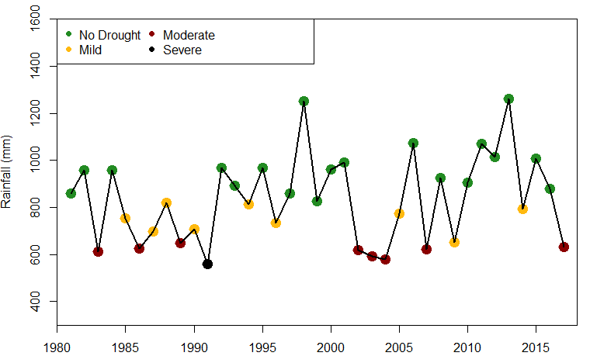

Figure 3: Annual time series of rainfall with drought category

# **Drought proofing assessment**

Drought proofing assessment is carried out using the developed conceptual drought proofing framework (**Figure 4**). In the framework, Drought proofing in a watershed is conceptualized as an interaction between water availability for crops and water use efficiency (Figure 4). At the base level, drought proofing is defined as an interaction between water availability for a crop (mm or m3 ha-1 or % of crop water needs met) and water use efficiency (Figure 4). Water availability for a crop is the water available from all the sources (rainfall, soil moisture, groundwater, and surface water storage) to meet crop water requirements. Water efficiency determines how efficiently irrigation water is used. For irrigated areas, this is the irrigation application efficiency. For rainfed areas, this can be translated to how efficiently rainfall is used.

Across a simple 2*2 plane, we can identify four distinct quadrants (**Figure 4**) with water availability for a crop on the y-axis and crop water use efficiency (WUE) on x-axis. Based on the analysis and where watershed crops lie in different rainfall years, users can identify the type and intensity of required interventions. Water availability can be increased with supply augmenting practices (storage, recharge, and soil moisture conservation) whereas water use efficiency can be increased through water saving and irrigation application efficiency measures (micro-irrigation).

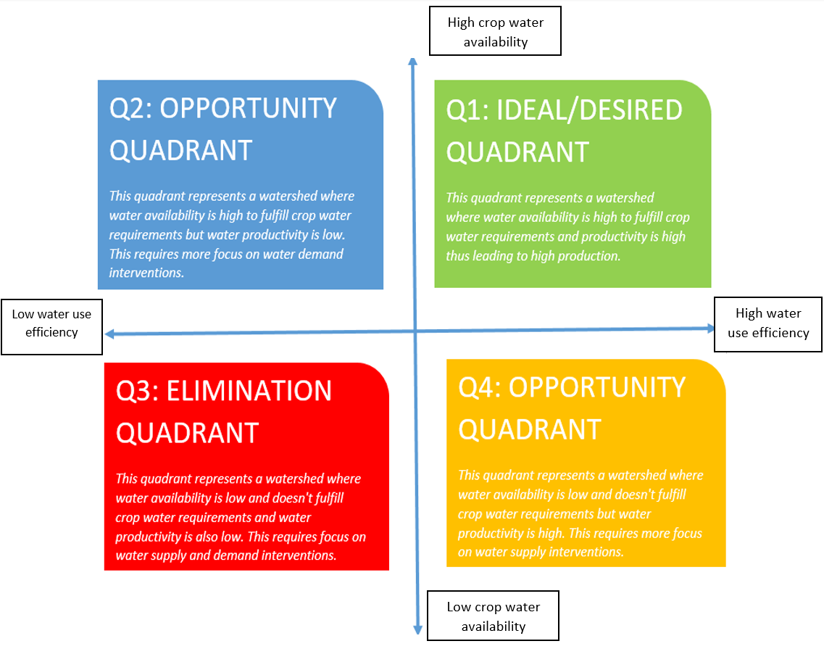

**Figure 4: Conceptual physical drought proofing framework**

With water as the key input to the drought-proofing framework (**Figure 4**), water balance tool is developed to operationalize the framework. The tool is modeled in excel spreadsheet with minimum input data requirements for simplifications. Drought Proofing Tool is developed in MS Excel + Visual Basic Editor (VBA) platform.

The water balance tool helps in site-specific water balance, crop yield, and crop requirement assessments. The two-key function of the tool is as follows:

* To assess the water balance of the study area for various hydrological conditions (dry, normal & wet years)
* To assess the impact of proposed water management interventions in achieving drought proofing

Here we provide the results of the application of the water balance tool for the watershed. For details on the methodological and workflow of the tool, please check Technical Manual, User Manual, and Case Study example.

# **Application of water balance tool**

The first step is the entry of input data. Input data to tool covers: Land use and soil data, crop details, irrigation and domestic and rainfall and temperature (see user manual). While a brief of each is provided in the study area description and summarised in Table 4, and detailed input data is given in Appendix A.

**Table 4:** **Overview of input data.** Detailed input data is given in Appendix A

|  |  |
| --- | --- |
| Parameter | Information |
| Land use | Table 1 |
| Soil | Clay loam (100 %) |
| Crops | Kharif: Tobacco |
| Rabi: Ragi (Finger millet) |
| Irrigation | Crop wise irrigated area, Groundwater irrigation 85 %, default irrigation efficiency of 0.5 |
| Rainfall and temperature | Daily rainfall, mean, max and min temperature data (20 years) |

The flow diagram (**Figure 5**) below gives the steps involved in running the tool and planning water management interventions.

* Step1: Input data is entered in the tool. See Appendix A and the user manual.
* Step 2: Baseline scenario is simulated. Baseline scenario is where no water management interventions are in place.
* Step 3: Water balance, crop water requirements, and crop water deficit results are analyzed
* Step 4: Based on analyzed results, water management interventions are planned and entered in the tool as scenarios
* Step 5: Scenarios are simulated and their impact on drought proofing is analyzed. If drought proofing is not realized, step 3 and 4 are repeated until the best results on drought proofing are obtained.

Accordingly, results in the upcoming section are given in the same order. As mild and moderate droughts are most frequent, drought proofing assessment is carried out for the same.

**Figure 5: Conceptual workflow of applying drought proofing tool**

### **Baseline scenario**

### **Water balance**

Table 5 gives the water balance results for the watershed for the normal, mild, and moderate drought years. Normal years include all years where rainfall is above the drought threshold, including wet years. The rainfall in mild and moderate years is lesser by 27 % and 46 % relative to normal years. In all years, runoff (4-9 % of rainfall) and recharge (4.7-10.2 % of rainfall) are low. Low runoff indicates well-distributed rainfall throughout the year. The highest runoff (8.9 % of rainfall) is in normal years. This shows that much of rainfall is converted to ET and there is little opportunity to further capture runoff for storage and recharge.

Table 5: Water balance results (in mm)

|  |  |  |  |  |
| --- | --- | --- | --- | --- |
| **Year** | **Rainfall** | **Runoff** | **recharge** | **ET** |
| Normal | 1050.8 | 90.5 | 31.4 | 928.9 |
| Mild | 761.8 | 33.6 | 23.1 | 705.1 |
| Moderate | 566.7 | 18.7 | 27.2 | 520.8 |

### **Crop water requirement and irrigation water requirement**

Table 6 gives the crop water requirement (CWR) and irrigation water requirement (IWR) of each simulated crop for normal, mild, and moderate drought years. CWR of the crop is calculated based on reference evapotranspiration (ETo). As there is a slight temperature difference between drought years, CWR differs among different drought years.

Tobacco CWR (400-410 mm) is relatively high as compared to rabi ragi CWR (255.6 mm). Irrigation water requirement (IWR) is the difference between CWR and rainfall in the crop growing period. As only Tobacco is irrigated (partially) in the watershed (Appendix A, Table 1b), IWR for Tobacco is estimated. Thus, IWR for Tobacco is limited only and is higher for moderate drought years when rainfall is lower.

Table 6: CWR & IWR of crop (in mm)

|  |  |  |  |  |  |  |  |
| --- | --- | --- | --- | --- | --- | --- | --- |
| Season | Crop | Normal | | Mild | | Moderate | |
| **CWR** | **IWR** | **CWR** | **IWR** | **CWR** | **IWR** |
| Kharif | **Tobacco** | 406.8 | 54.4 | 400.2 | 68.1 | 410.9 | 170.1 |
| Rabi | **Ragi** | 255.6 | - | 253.9 | - | 256.6 | - |

### **Crop water requirement met and crop yield**

CWR is met by rainfall and soil moisture in the case of rainfed crops whereas irrigated areas can also access irrigation storage to meet CWR. For this reason, CWR met (% of CWR needs fulfilled) of irrigated Tobacco crop is higher than the rainfed Tobacco (Table 7).

Results show that for normal years, most of CWR is met for Tobacco (~ 90 %) and Ragi (~ 95 %). This is expected in normal years as rainfall is high meaning low IWR, and recharge is also high to provide irrigation if needed. For Tobacco and Ragi, the impact of mild drought on crops remains limited with CWR met remaining high (above 80 %). This reflects that CWR in the watershed is relatively low and compared to mild year rainfall (761 mm) which is sufficient to meet CWR. Only a slight reduction in meeting CWR happens.

However, this is not the case for moderate drought. Low rainfall (566.7 mm) during moderate drought year is not sufficient to meet CWR. CWR met ranges from 58-62 % for Tobacco and 70 % for ragi. However, results show that if Tobacco is provided supplemental irrigation, the impact of drought can be mitigated (100 % CWR met. Currently, only a small area of Tobacco is under supplemental irrigation, and increasing this can be a potential drought proofing strategy. However, low recharge in moderate years (Table 5) means that providing supplemental irrigation of all Tobacco may not be possible where irrigation demand is high (Table 6).

Table 7: Percent of total CWR met for each crop in different drought years

|  |  |  |  |  |  |  |  |
| --- | --- | --- | --- | --- | --- | --- | --- |
| Season | Crop | Normal | | Mild | | Moderate | |
| **Irrigated** | **rainfed** | **Irrigated** | **rainfed** | **Irrigated** | **rainfed** |
| Kharif | **Tobacco** | 100% | 86.6% | 100% | 83.0% | 100% | 58.6% |
| Rabi | **Ragi** | - | 91.6% | - | 85.9% | - | 70.8% |

Crop yield (as % of attainable yield) is influenced by how much CWR is met (Table 7) and how sensitive it is to water deficits (Steduto et al., 2012). Crop yields (Table 8) follow the same trend as CWR met in Table 7. The crop yield of Tobacco and Ragi is significantly impacted in moderate drought years. This shows that interventions should primarily focus on increasing the CWR met for both crops in moderate drought years.

Table 8: Crop yield (as % of attainable yield) in different drought years

|  |  |  |  |  |  |  |  |
| --- | --- | --- | --- | --- | --- | --- | --- |
| Season | Crop | Normal | | Mild | | Moderate | |
| **Irrigated** | **rainfed** | **Irrigated** | **rainfed** | **Irrigated** | **rainfed** |
| Kharif | **Tobacco** | 100 % | 88.0% | 100 % | 84.7% | 100 % | 62.7% |
| Rabi | **Ragi** | - | 92.5% | - | 87.3% | - | 73.7% |

### **Drought proofing and Quadrant**

Plotting CWR met and irrigation efficiency of the crop on drought proofing quadrant (**Figure 6**) shows which crop and what kind of interventions are needed. As discussed above, it becomes clearer that both crop in mild years already lies in the desired drought proofing quadrant (1) and need little additional interventions. Interventions on supply and soil moisture can further improve the water availability and yield of both crops. However, for moderate drought years, CWR met and irrigation efficiency is both low. Thus, moderate years requires taking both supply and demand interventions.

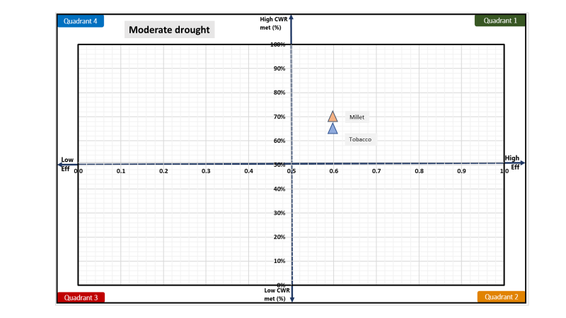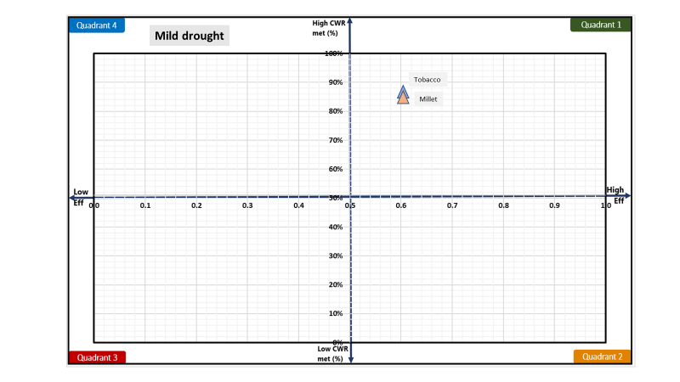

**Figure 6: Drought quadrant for mild (left) and moderate (right) drought**

# **Plan water management interventions**

Crop water balance and deficit (CWR met) shows which crops are impacted the most and drought proofing quadrant shows which interventions are needed. However, the intensity or scale of water management interventions should be planned based on how much water is available and absolute crop deficits (in m3). Crop water deficits (CWR – CWR met) can be assessed from results on CWR (Table 6) and CWR met (Table 7). Table 9 gives the crop water deficit (in m3) for all crops for mild and moderate drought years. Crop water deficit (in m3) is derived by multiplying unmet CWR (in mm) to the crop area.

Results show that there is a high absolute water deficit for Tobacco and Ragi in moderate drought years. This is driven by low CWR met (%) as given in Table 7. Absolute water deficit (in m3) for moderate drought years is almost 8 times the deficit in mild drought years. Also, much of it is concentrated in Tobacco showing moderate drought impacting the Tobacco crop more. Absolute crop water deficit (in m3) can give an idea of how much additional storage interventions to plan.

In addition to supply measures, water-saving can be achieved through improving irrigation efficiency measures. Table 9 also gives the potential savings that can be achieved if irrigation efficiency is improved to 0.75 and 0.9 for all crops. Potential savings (in m3) are derived assuming all irrigation water requirement (IWR) is met through increased efficiency. Calculations show that savings from increased irrigation efficiency in Tobacco can only cover 5-7 % of absolute crop water deficits. This shows that watershed in a moderate drought year is limited by water availability and increased efficiency will add little benefits as water in irrigation storage is limited.

Table 9: Absolute crop water deficit and potential saving from increasing irrigation efficiency for mild and moderate drought years.

|  |  |  |  |  |  |  |  |
| --- | --- | --- | --- | --- | --- | --- | --- |
| **Season** | **Crop** | **Mild** | | | **Moderate** | | |
| **Deficit (‘000 m3)a** | **Potential savings (‘000 m3)b** | | **Deficit (‘000 m3)** | **Potential savings (‘000 m3)** | |
|  | Eff =0.75 | Eff = 0.9 |  | Eff = 0.75 | Eff = 0.9 |
| **Kharif** | Tobacco | 195 | 68 | 170 | 2898 | 142 | 283 |
| **Rabi** | Ragi | 336 | 0 | 0 | 1178 | 0 | 0 |
|  | Total | 531 | 68 | 170 | 4076 | 142 | 283 |

a deficit = [CWR*(1- CWRmet(%)]*Crop area

b savings = [(IWR/effc) - (IWR/effim)]*Crop area, where effc and effim is the current and improved irrigation efficiency.

Table 10 compares the total deficit and total potential irrigation savings to available water. Available water is the runoff in the area which can be captured for storage or recharge to meet crop water deficits. The comparison shows that for mild drought years, available water is limited but if captured to an extent can cover the deficit meaning supply side interventions can potentially mitigate the drought impact. Along with irrigation efficiency-improving measures, there is potential to completely mitigate the impact of mild drought. However, for moderate drought years, available water is not sufficient to meet the crop water deficit. Drought proofing moderate years potentially will require interventions such as shifting or reducing crop area of high-water consuming crops.

Table 10: Comparison of total available water with the total deficit and irrigation potential savings (in m3)

|  |  |  |  |  |  |
| --- | --- | --- | --- | --- | --- |
|  | Available watera | Total deficit | Potential savings [0.75] |  | Potential savings [0.9] |
| Mild | 781 | 531 | 68 |  | 142 |
| Moderate | 446 | 4076 | 70 |  | 283 |

a runoff*Watershed area

## **Water management interventions scenarios**

For planning water management interventions, we focus primarily on drought proofing moderate drought years as in mild drought years CWR met and yield remains high. Also, as the results show (Table 9 and 10), only interventions that build supply or improve irrigation efficiency measure cannot achieve drought proofing. Other than infrastructure, there is a need for management in terms of irrigation and shifting crop area to less water-consuming crops in moderate drought years. Based on the deficit and available water, the following initial 3 scenarios are designed and simulated (**Table 11**).

Results show that for irrigated Tobacco 100 % of CWR is met. So, focus of interventions is to cover more area under irrigation and capture additional available water through on-farm water storage so that additional area can be provided supplemental irrigation. Thereafter, we focus on the efficient application of irrigation. However, available water is not enough to provide the entire tobacco cultivated area with supplemental irrigation. Thus, the third strategy is to shift tobacco cultivated area to rainfed red gram (long duration 180 days) which has lower CWR and its requirement are distributed thus can utilize long-duration rainfall in the watershed much better.

**Table 12** gives input parameters of the interventions added to the model. For details of parameters or step-by-step instructions on how to run scenarios, please see [user manual](https://drive.google.com/drive/folders/1Yi0Qt4JraRVXNljxe3DB_TAdu5VM8bhg).

**Table 11: Water management interventions under different scenarios**

|  |  |  |
| --- | --- | --- |
|  | Scenario | Interventions |
| 1 | Increasing area under supplemental irrigation and building on-farm water storage | * Increasing Tobacco area covered with irrigation to 600 ha * Building 200 farm ponds (storage of 200000 m3) |
| 2 | Increasing application efficiency of Tobacco | * Further increase Tobacco irrigated area by 200 ha * Providing drip irrigation or through manual precision irrigation for each plan (efficiency to 0.9) to Tobacco irrigated area |
| 3 | Reducing Tobacco rainfed area | * Replacing Tobacco rainfed area with long duration rainfed red gram (700 ha) |

**Table 12: Input parameters of water management interventions**

|  |  |  |
| --- | --- | --- |
| Interventions | Impact/technical parameters | Cost, Life span, maintenance, |
| Farm ponds | Storage: 675 m3  Depth: 2.5 m  Infiltration rate: 7 mm day-1 | Cost: 80 INR m-3  Annual maintenance: 0 %  Life span: 10 years |
| Drip irrigation | Increased efficiency: 0.9 | Cost: 60000 INR ha-1  Maintenance: 6%  Life span: 8 |

## **Interventions impact on moderate drought**

**Figure 7** shows the impact of interventions on the runoff and recharge in the watershed for moderate drought years. Runoff decreases to almost negligible after scenario 1 which includes the building of on-farm storages. Additionally, there is a small increase in recharge coming from infiltration from farm ponds. However, absolute changes are minimal as runoff in the baseline scenario is very limited. In total, the reduction in runoff is 13 mm which represents the additional storage created by farm ponds.

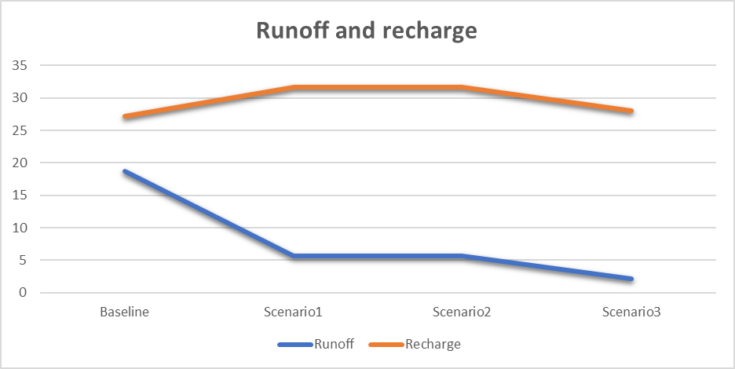

**Figure 7: Impact of interventions on the runoff and recharge in the watershed for moderate years**

The impact of increased storage and increased supplemental irrigation is visible in Figure 8. With the increase in irrigated areas, the yield of the overall irrigated area decreases. This is because as available water and additional storage created is not sufficient to meet irrigation water demand from the increased area. However, in scenario 2 with increased efficiency of irrigation, yield increases again to 100 %. This is despite the increased Tobacco irrigated area (Table 11, scenario 2). Thus, results show that with increasing on-farm storage and highly efficient irrigation, almost half of the tobacco area can be covered with supplemental irrigation which is critical for drought proofing. However, rainfed tobacco yield remains at ~60 %. However, due to limited rainfall and runoff, only about half of the Tobacco area (800 ha of 1760 ha) can be drought proofed.

Thus scenario 3 envisages that 700 ha of Tobacco is replaced with long-duration kharif red gram. Figure 8 shows that without irrigation, red gram can yield ~ 75 % of attainable yield in a moderate drought year, which is much higher than the rainfed Tobacco yield of 60%. Thus, it will be prudent to increase the red gram area in the watershed for moderate drought years so that rainfed Tobacco can be saved from severe scarcity of water. For ragi, there is no change in yield and yield remains ~74 % of attainable yield. The high yield of ragi and red gram highlights their drought-resistant qualities.

**Figure 8: Crop yield (% of attainable yield) under different scenarios for moderate years**

*For crops with both rainfed and irrigated areas, area-weighted yield is shown.

The actual impact of developing supplemental irrigation and shifting crop area becomes more apparent when drought proofing is considered for the whole watershed (Figure 9). Percent drought proofing represents total crop production of the watershed as a percent of total potential crop production (i.e. production without any water stress) under different scenarios. The plot shows that drought proofing is low (71 %) under the baseline scenario and gradually increases to 79 % in scenario 3. Given very low rainfall and runoff in moderate drought years, achieving 79 % of watershed production in moderate drought years represents a good result and is almost equal to drought proofing target of 80 %.

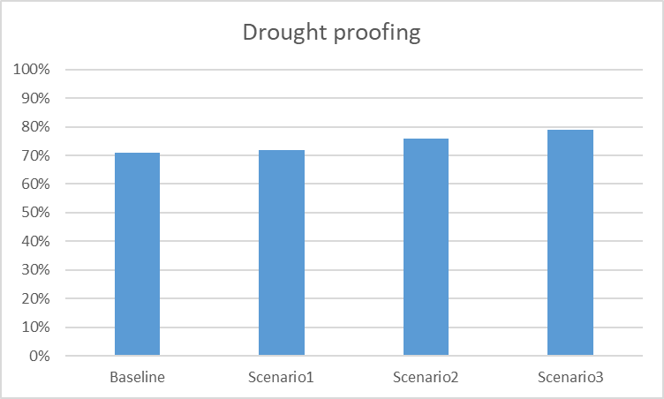

**Figure 9: Overall watershed drought proofing percentage under different scenarios for moderate years**

**Figure 10** shows the impact of interventions on drought proofing quadrant. Increased CWR met and increased efficiency is visible for the Tobacco crop moving further towards the right top corner in quadrant 1 (desirable quadrant). There is no change for ragi (millet) where the CWR remains around ~ 71 %.

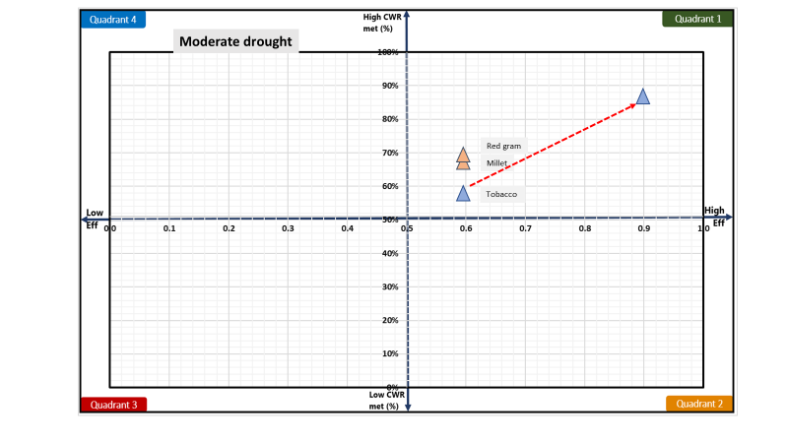

**Figure 10: Impact of interventions visualised on drought proofing quadrant**

# **Conclusion and recommendation**

Ravanduru watershed faces frequent mild and moderate drought. Over the last 15 years, 5 years have been moderate drought year whereas 3 years have been mild drought. Analysis of water balance and deficit shows that the impact of mild drought is limited but moderate drought severely impacts crop production as most of the area is rainfed. The impact is more acutely observed for rainfed Tobacco crop where yield reduces to 60 % of attainable yield. Ragi with lower CWR and more drought resilient can still achieve yield up to ~ 75 % of attainable yield. Additionally, in moderate drought years, there is very limited runoff to fill the supply and demand gap. Thus, to mitigate the impact of drought, management measures on supplemental irrigation and crop choices are clubbed with limited supply and demand interventions. Simulation shows that building on-farm storage with the efficient application of irrigation can bring additional rainfed Tobacco area under supplemental irrigation. However, only 45 % of the cultivated area can be brought under irrigation and the rest remains drought prone. For that, there is a need to shift rainfed Tobacco area to rainfed red gram which due to its CWR distributed over a longer duration fair well in moderate drought years. Doing this also increases the overall drought proofing percentage of the watershed. Developed scenarios and results provide the rationale for planning investment and implementation of the interventions in the watershed.

**References**

CGWB, 2013. Groundwater information Mysore district, Karnataka. Ministry of Water Resources Central Ground Water, Government of India. WESTERN REGION JAIPUR

Sönmez, F.Kemal., Kömüscü, A.Ü., Erkan, A., Turgu, E., 2005. An Analysis of Spatial and Temporal Dimension of Drought Vulnerability in Turkey Using the Standardized Precipitation Index. Natural Hazards 35, 243–264. <https://doi.org/10.1007/s11069-004-5704-7>

Steduto P, Hsiao TC, Fereres E, Raes D. 2012. Crop Yield Response toWater. Food and Agriculture Organization of the United Nations: Rome, Italy.

World Bank, 2019. Assessing Drought Hazard and Risk: Principles and Implementation Guidance. Washington, DC: World Bank. Link: <https://www.droughtmanagement.info/literature/WBG_Assessing_drought_hazard_and_risk.pdf>

# **Appendix A: Input data**

Table 1A: Land use details

|  |  |  |
| --- | --- | --- |
| **S.no** | **Description** | **Area (ha)** |
| **Total Agri catchment Area (ha)** | | 2268 |
|  | Agriculture Area (Net cultivated sown area) | 1865 |
|  | Fallow | 37.41 |
|  | Built-up / Settlements | 68.32 |
|  | Water bodies | 128.35 |
|  | Pasture | 28.5 |
|  | Forest | 130.30 |
|  | Other | 27.12 |

**Table 1B: Soil Data**

|  |  |  |  |  |  |
| --- | --- | --- | --- | --- | --- |
| **S.no** | **Soil Typea** | **Soil Depth (m)** | **Soil Distribution**  **(%)** | **Infiltration Rate (mm/hr)** | **Ground Water Yield of area (l/s)** |
|  | Clay Loam | 0.70 | 100% | 5-10 | 0.5-3.2 |

Table 1C: Cropping pattern details

|  |  |  |  |  |  |  |  |
| --- | --- | --- | --- | --- | --- | --- | --- |
| **Area** | **Crop name** | **Area Sown (ha)** | **Irrigation (ha)** | | **Crop Duration (days)** | **Crop Sowing Date** | |
| **Irrigated** | **Rainfed** | **Month** | **Week** |
| Kharif | | | | | | | |
| Area 1 | Tobacco | 1780 | 280 | 1500 | 120 | May | 1 |
| Area 2 | Red gram | - | - | - | 180 | May | 1 |
| Rabi | | | | | | | |
| Area 1 | Ragi | 1803 | 1803 | 0 | 130 | Sep | 1 |

aAs only 3 major crops are allowed: Groundnut area with Maize and gram area to coriander. This is done as to not to underestimate water requirements.

Table 1D: Crop details

|  |  |  |
| --- | --- | --- |
| **Crop name** | **Crop yield (tonne/ha)** | **Price (Rs/Tonne)** |
| Tobacco | 2 | 140000 |
| Ragi | 3.5 | 26000 |
| Red gram | 2.4 | 44000 |

Table 1E: irrigation & domestic details

|  |  |  |  |  |
| --- | --- | --- | --- | --- |
| **Irrigation Source** | **Area (%)** | **Irrigation efficiency** | **Residual storage** | **Non-Renewable storage** |
| Irrigation | | | | |
| **Groundwater** | 30 | 0.5 | 0 | No |
| **Surface water** | 70 | 0.5 | 0 |  |
| Domestic | | | | |
| **Population** | Daily water usage (LPD) | GW dependent | SW dependent |  |
| 9567 | 70 | 100 | 0 |  |